Lab Exercise #3

Task 1: Consider the following 8 bytes of data:
LFh, 45h, 89h, 4Ch, 2Ah, 58h, 64h, 37h
Write a program to store the given block of data bytes in memory locations starting from 0200h. List the addressing modes used in the process. Use the debug option and observe the data. Attach the image with your solution.

Code:
mov [0200h],1fh
mov [0201h],45h
mov [0202h],89h
mov [0203h],4ch
mov [0204h],2ah
mov [0205h],58h
mov [0206h],64h
mov [0207h],37h

Addressing mode: Direct addressing mode

Output:
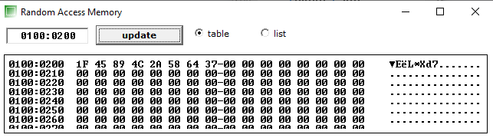

Task 2: Write a program to move the block of data, given in Acitivity-1, from locations 0200-0207 to memory locations 0400h -0407h using direct addressing mode. Run the program step- by-step and analyze each step. Attach the image with your solution.

Code:
mov al,[0200h]
mov [0400h],al

mov al,[0201h]
mov [0401h],al

mov al,[0202h]
mov [0402h],al

mov al,[0203h]
mov [0403h],al

mov al,[0204h]
mov [0404h],al

mov al,[0205h]
mov [0405h],al

mov al,[0206h]
mov [0406h],al

mov al,[0207h]
mov [0407h],al

Addressing mode: Direct addressing mode

Output:
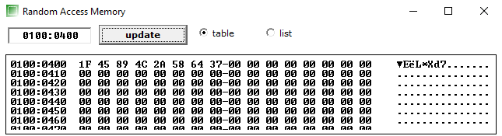

Task 3: Write a program to move the block of data, given in Acitivity-1, from locations 0200-0207 to memory locations 0400h -0407h using register indirect addressing mode. Use the debug option and observe the data. Attach the image with your solution.

Code:
mov bx,0200h
mov al,[bx]
mov [0400h],al

mov bx,0201h
mov al,[bx]
mov [0401h],al

mov bx,0202h
mov al,[bx]
mov [0402h],al

mov bx,0203h
mov al,[bx]
mov [0403h],al

mov bx,0204h
mov al,[bx]
mov [0404h],al

mov bx,0205h
mov al,[bx]
mov [0405h],al

mov bx,0206h
mov al,[bx]
mov [0406h],al

mov bx,0207h
mov al,[bx]
mov [0407h],al

Addressing mode: Register indirect addressing mode

Output:
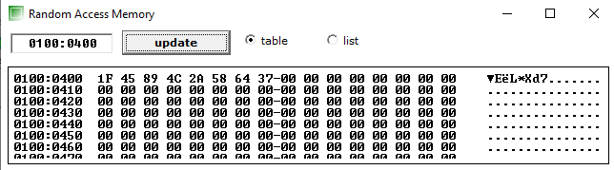

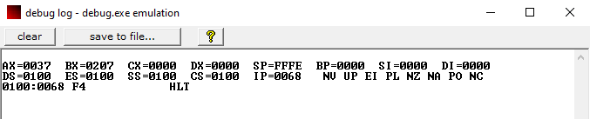

Task 4: Write a program to swap the bytes from locations 0501h, 0503h, 0505h, and 0507h with the locations 0701h, 0703h, 0705h, 0707h respectively using
- Based-relative addressing mode
- Indexed-relative addressing mode

Based-relative addressing mode

Code:
mov bx,0501h
mov al,[bx]

mov bp,0701h
mov dl,[bp]

xchg al,dl

mov [0501h],al
mov [0701h],al

mov al,[bx]+2
mov dl,[bp]+2
xchg al,dl
mov [0503h],al
mov [0703h],al

mov al,[bx]+4
mov dl,[bp]+4
xchg al,dl
mov [0505h],al
mov [0705h],al

mov al,[bx]+6
mov dl,[bp]+6
xchg al,dl
mov [0507h],al
mov [0707h],al
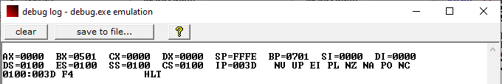

Index-relative addressing mode

Code:

mov si,0501h
mov al,[si]

mov bp,0701h
mov dl,[bp]

xchg al,dl

mov [0501h],al
mov [0701h],al

mov al,[si]+2
mov dl,[bp]+2
xchg al,dl
mov [0503h],al
mov [0703h],al

mov al,[si]+4
mov dl,[bp]+4
xchg al,dl
mov [0505h],al
mov [0705h],al

mov al,[si]+6
mov dl,[bp]+6
xchg al,dl
mov [0507h],al
mov [0707h],al





